## After update the gis table – fields

## Need to add the permission back.

By ArcGIS

For example, need to update permission for table SUBDIVISION

1. Open SQL Developer
2. Open table SUBDIVISION
3. Under GRANTS



1. Take a screen shot of its current’s permission setting before editing.

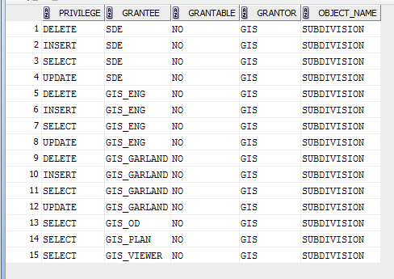

1. Open ArcCatalog
2. Find SUBDIVISION under GIS.Engineer

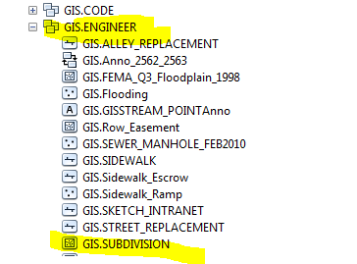

1. Right click GIS.ENGINEER

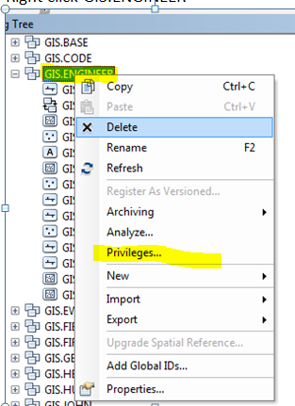

1. Click Privileges…
2. Update

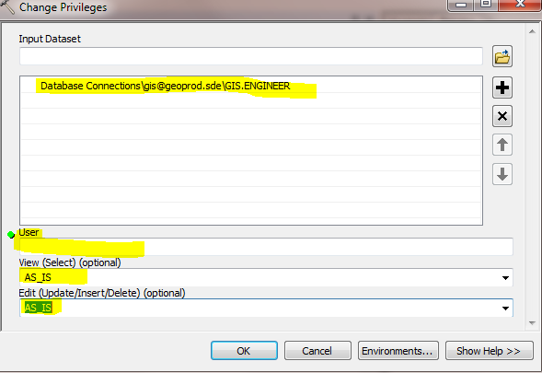

By SQL Developer

1. Right Click table 🡪 Privileges 🡪 Grant

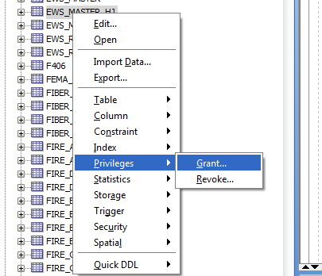

1. Select “Users” 🡪 Add permissions 🡪 Apply

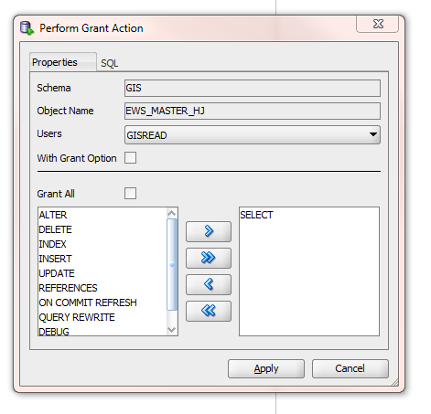

1. Do step 2 again to add all users.